**G**

[Services title]

Created for: Customer

[Date]



***Bridging the software quality maturity gap***

|  |  |
| --- | --- |
| Orasi Software Services | Orasi Account Executive |
| Caleb Billingsley  Senior VP of Professional Services | [name] |
| (770) 377-9309 | [phone] |
| Caleb.Billingsley@Orasi.com | [email] |

Orasi Software, Inc.⦁ 114 TownPark Drive, Suite 400 ⦁ Kennesaw, Georgia 30144 ⦁ Tel 678.819.5300 ⦁ Fax 678.819.5301 ⦁ [www.orasi.com](http://www.orasi.com)

**Orasi Services Statement of Work**

Table of Contents

Article 1: Scope & Terms 3

Article 2: Contact and Logistics Information 3

Article 3: Customer Responsibilities 4

Article 4: Assumptions 4

Article 5: Schedule Parameters 4

Article 6: Travel and Expenses 5

Article 7: Acceptance and Signatures 6

**ORASI STATEMENT OF WORK (SOW) # [SF-OPP-#]**

This Statement of Work (hereafter “SOW”) defines the scope of services to be performed by Orasi Software Inc. (hereafter “Orasi”) for Customer (hereafter “Customer”) subject to the terms of the Master Services Agreement (“Agreement”) entered into by Orasi and Customer on **[Date MSA was signed]**.

If there is no MSA, simply put

This Statement of Work (hereafter “SOW”) defines the scope of services to be performed by Orasi Software Inc. (hereafter “Orasi”) for Customer (hereafter “Customer”).

# Article 1: Scope & Terms

**Scope:**

[Add a descriptive paragraph describing the services and general goal. This lets us lead off by stating the goal of the work. Without it, the document has no context. If we add this section in and use it properly, I feel we can keep the services work order as it is now, in the addendum.] For example, “Customer has contracted with Orasi to provide HPE Performance Center upgrade services from HPE Performance Center version 10 to HPE Performance Center version 12 and to migrate up to 100 HPE Performance Center projects from HPE PC v10 to HPE PC v12.”

The scope of services performed under this SOW include those described in the Addendums of this document and any additional or new services to which the Parties mutually agree in a written Change Order. Provisions for extension of this SOW may be available by contacting the Orasi Services Delivery Manager, who will process an appropriate Change Order.

**Term:**

Consulting Services will begin on a mutually agreeable date only after the execution of this SOW. Orasi requests a two (2) week lead time between the signing of this SOW and the start of services when feasible.

**Investment:**

The cost of the services is $[Total Amount]. Services are billed on a not to exceed basis. Any travel and expenses incurred by Orasi will be invoiced separately from the above total. See Addendums for a detailed breakout of costs. Payment terms are net 30 days of invoice date or as set forth in a current MSA/PSA.

The prices, rates, and discounts provided in this quote or SOW are contingent upon customer accepting reasonable contract terms as determined by Orasi.  If customer requires Orasi to accept additional risks related to liability, payment terms, or non-solicitation of employees, then discounts and/or favorable pricing may not be available.

**Orasi Performance Testing Approach**

Orasi consultant will work with the customer team to fully scope the load test, deliverables, application modules and hardware for system under test and create a performance test plan. The performance test plan will focus on the goals of the test and any limitations. According to Wikipedia (because there are many definitions in the world of performance), there are 6 core types of performance testing. They are Load Testing, Stress Testing, Endurance Testing, Spike Testing, Configuration testing, and Isolation testing. This SOW will define the goal types in the deliverables section. The SOW will likely not include scope for all types.

*Load Testing* refers to running the system at normal production loads and at Orasi we like to use the terms Low Capacity Load Test, Normal Capacity Load Test and High Capacity Load Test to indicate if the system is being run at low, normal, or high loads. The goal of a Load Test is to tell you the expected response times of the system at loads expected in production.

*Stress Testing* is focusing on the upper limits of the system. The goal of stress testing is to determine the bottlenecks that occur in the system.

*Endurance testing* focuses on memory leaks and other stability factors a system can encounter from running at high capacity for extended durations. (Normally at least 6-8 hours, but possibly longer depending on the system under test.)

The idea of *spike testing* is if your business could get a short burst of traffic, can the system handle the burst. Our preference is to ensure the system can handle a sustained high capacity which is similar to spikes but for a longer test. We most often see requests for spike testing if specific business needs require it such as you are running an ad on black Friday or a super bowl ad.

*Configuration testing* is when you want to run the same performance test and analyze the impact of the configuration changes at the database, operating system, network, or application tiers.

*Finally, Isolation and Tuning testing* is when we performance test a single function in the system to confirm its limits and possible contributions to a failure. You can also use isolation testing to test code based changes to help with a fault area.

It is important to realize that some types of performance testing such as a Normal Capacity Load Test can be completed in 1-3 weeks, while others such as configuration and isolation can take months to complete all the test cases. The addendum – engagement deliverables section will outline what types of testing Orasi consultants are going to perform. If we are running only Capacity testing, then the goal is to provide you with numbers that show the performance of your system. If you want to perform tuning, then you need to specifically request configuration testing or isolation and tuning testing. In addition, we will need to either name a maximum number of configurations or test runs.

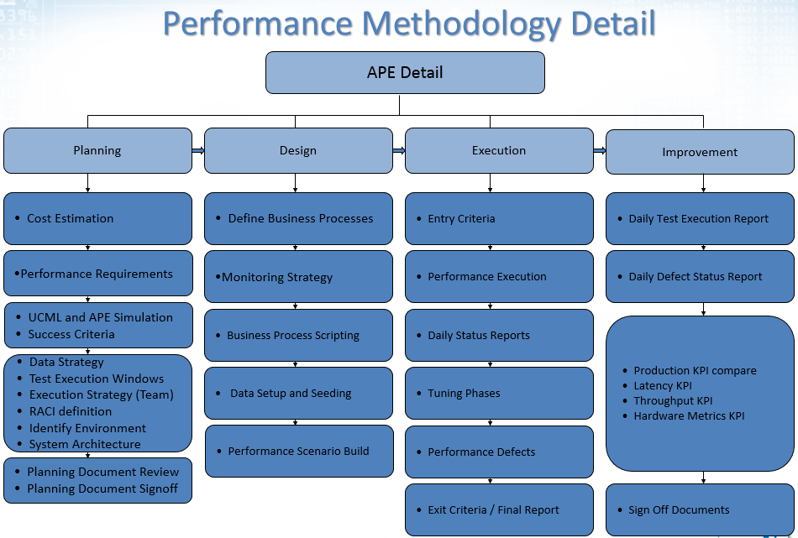

**Performance Business Process Scripting**

The SOW allows for up to a set number of business process scripts to be developed that will mimic the highest volume business transactions against the application under test. This limit is defined in the addendum 1 – engagement deliverables. The distribution of these available scripts will be made during the planning phase. A script is defined as a business process that doesn’t exceed 10 web pages/screens or 50 clicks/edits. The performance plan will be built from input from the customer. Certain scripts may be replayed at a higher volume to achieve the overall hits per second required to mimic production and/or production + growth.

The scripts will be generated through “recording” the activity generated by executing the business processes manually through the user interface or programmatically such as web service calls. Having an accurate copy of the test case that works in the performance environment on the start of the engagement is essential to success of the project. This is a customer responsibility and listed in the customer responsibilities section.

The initial recording will then be modified to allow for data parameterization and measurement of system performance through the insertion of “transaction markers” which measure the time between a request to the system and a response. In addition, every effort will be made to “modularize” the scripts for maximum re-use of code which will save significant time both in script generation and maintenance.

Following the creation and testing of the scripted business process suite with the data necessary to simulate daily system activity, scenarios will be created which consist of a specified combination of scripts executed by multiple “virtual users” (up to the Virtual User license limit) to mimic daily average and peak system load as well as any other critical load scenarios such as ultimate load failure.

These scenarios will then be executed to measure system performance both from a “system response time” perspective and a “system resource” perspective (e.g. CPU, memory, etc as well as specific metrics pertaining to Diagnostics and the database servers). System bottlenecks can then be identified by correlating user activity in terms of transaction response time to system resource metrics during the analysis phase. Once bottlenecks have been identified and resolved, re-testing will occur to verify the effectiveness of system modifications and tuning.

# Article 2: Contact and Logistics Information

|  |  |  |
| --- | --- | --- |
| **Customer Point of Contact** | **Services Location** | **Billing Address** |
| [Customer Contact Info]  [Title]  [Phone]  [Email] | Customer  [Street Address]  [City, State Zip] | Customer  [Street Address]  [City, State Zip] |

# Article 3: Customer Responsibilities

| **#** | **Responsibility** |
| --- | --- |
|  | When applicable, providing a copy of travel policies and guidelines prior to Orasi consultants arranging travel. |
|  | Identifying a primary point of contact for the overall project. |
|  | Providing Orasi consultants with workspace and/or access to conduct their activities, whether working onsite or remotely, when applicable. Consultant must also have access to necessary Customer applications, shared drives and document repositories when applicable. |
|  | When applicable, ensuring the Orasi consultants have security access privileges for buildings or areas granted prior to beginning this engagement and for the duration of the engagement. |
|  | Ensure the Orasi consultants working at customer locations have access to the Internet for corporate email, research and other reasonable project activities. |

Note: See Services Work Order(s) for project-specific customer responsibilities.

# Article 4: Assumptions

|  |  |
| --- | --- |
| **#** | **Assumptions** |
|  | The estimates provided in this SOW do not account for rework in Orasi’s deliverables due to changes to the customer’s application(s) under test, test data, test environments, or requirements. |
|  | Orasi consultants will perform the work described in this SOW without stoppages or delays caused by the customer, the application under test, customer test environments, or other reasons within control of the customer. |

Note: See Services Work Order(s) for project-specific assumptions.

# Article 5: Schedule Parameters

| **#** | **Project Scheduling & Delays** |
| --- | --- |
|  | Services are to be delivered during normal business hours Monday – Friday. |
|  | Prior Customer and Orasi approval is required any time over 45 hours are invoiced per week and/or weekend/holiday hours. |
|  | Orasi consultants will be scheduled to start work at a date mutually agreed upon by Orasi and Customer. Customer-initiated delays in the start date may result in consultants being rescheduled to other projects or additional costs to the customer to hold the consultants. |
|  | Orasi cannot be held responsible for delays or problems caused by:   1. Inaccurate information provided by customer. 2. Defects in third party software, including HPE. 3. Lack of availability of required Customer resources such as subject matter experts.   If any of the above issues are present, Orasi will use commercially reasonable efforts to remedy the situation and minimize the impact on the Customer’s project and objectives.  However, delays caused by the above issues can reduce the effectiveness and efficiency of the services that Orasi provides and may increase costs. |

# Article 6: Travel and Expenses

|  |  |
| --- | --- |
| **#** | **Responsibility** |
|  | Orasi will comply with Customer’s travel policy, if one is in place. |
|  | If Customer travel policy is not in place, Orasi will make commercially reasonable efforts to control costs and adhere to travel and expense policies. Orasi’s ability to control costs is dependent upon having adequate lead time to make travel arrangements. |
|  | The customer will be responsible for travel and expense costs that exceed any maximum or set limits in situations where the Customer requests consultants to be onsite with less than two weeks lead time. |
|  | Customer will also be responsible for additional costs related to any changes requested by the Customer to the Orasi consultant's schedule (e.g., postponement of a previously agreed to engagement start date). |

# Article 7: Acceptance and Signatures

**Warranty and Indemnity**

Orasi warrants to the Customer that the services will be performed consistent with applicable professional standards recognized in the industry. Orasi is responsible for the professional quality, technical accuracy, completeness, and coordination of the services. If Orasi fails to meet applicable professional standards, Orasi shall correct or revise any errors or deficiencies without additional compensation.

*NOTE: Orasi is not responsible for defects, shortcomings, or incompatibilities in software or hardware (third-party products) related to the services provided in this SOW.   Issues with third-party products, including software, shall be referred to the appropriate vendor and product support arrangements made by the customer.  The costs of resolving defects and issues in third-party products are the responsibility of the vendor and the Customer, not Orasi.  Orasi will make commercially reasonable efforts to assist in the resolution or remediation of any issues discovered; however, this may result in extended effort and costs that are unknown at the time of this estimate.*

**Review and Acknowledgement**

Before Orasi consultants can begin delivering services under this SOW, Customer must sign this Statement of Work and issue a Purchase Order referencing this SOW, and the Consulting Services Agreement, if one is in place. Orasi shall not have any liability, whether based in contract, tort (including negligence) or any other legal theory, for indirect, consequential, incidental, special or punitive damages of any kind even if the parties have been advised of the possibility of such damages. Orasi’s maximum liability for damages arising out of or relating to this proposal, whether based in contract, tort, or any other legal theory, will not exceed the amounts paid hereunder for the particular Services giving rise to the cause of action.

Customer understands and agrees that the services and deliverables defined herein are what Orasi and the customer have agreed to.  Any oral or written comments provided by Orasi or any of its representatives that are not contained in this SOW are not part of the agreement.

**Signatures**

The Parties’ authorized representatives have executed this Statement of Work by their signatures below:

|  |  |
| --- | --- |
| **Customer**  By: ____________________________________  Name: __________________________________  Title: ___________________________________ | **Orasi**  By: ___________________________________  Name: ________________________________  Title: _________________________________ |
| Date**:**  __________________________________ | Date: _________________________________ |

# Services Work Order # 1: Some Services

## References

|  |  |
| --- | --- |
| Orasi SOW ID |  |
| Services Work Authorization Contact |  |

## Engagement Scope

Customer has contracted with Orasi to XYZ. The objective is ABC.

* Do stuff
* Do more stuff
* Do all stuff

### Engagement Activities

|  |  |
| --- | --- |
|  | Activities |
|  |  |
|  |  |

### Engagement Deliverables

|  |  |
| --- | --- |
|  | Deliverables |
|  |  |
|  |  |

## Engagement Specific Customer Responsibilities / Assumptions

1. Customer must provide all hardware upon which any tooling, including but not limited to the HPE LoadRunner Controller, Load Generator, SiteScope applications will be installed on Customer’s network.
2. Customer must provide authentication credentials which HPE SiteScope can use to connect to target servers, with appropriate privileges to execute polling functions.
3. Customer must provide access to SME’s, as required, to facilitate resolving any barriers with regard to system access and privilege levels.
4. Provide access to SMEs to guide Orasi’s consultant into the creation of a performance test optimized test case.
5. All data models in the application database(s) are in place, the GUI for each application is in a stable state, and business rules are complete and available to the Orasi team as needed prior and during the engagement.
6. Environment that is being used for test development and performance testing is dedicated to performance team. The environment should be stable and any code release changes should be on a published schedule.
7. Customer to provide all Master data for testing the full load & performance test. This quantity of data would be determined in the engagement, but often is 100’s or 1000’s of data to simulate a day in the life of production. Master data is data a system is populated with after conversion such as vendor numbers, product SKU’s, factory IDs, employee numbers, login ID’s, etc.

## Engagement Costs

|  |  |  |  |
| --- | --- | --- | --- |
| Role | Resource Count | Hours | Total |
|  |  |  | **$0,00000** |
|  |  |  | **$0,000.00** |
| *Total* |  |  | **$00,000.00** |

*Note: Travel and expenses will be invoiced separately, as actuals.*

*Important Notice*

The estimated engagement costs are dependent upon the assumptions documented above and the customer meeting the responsibilities described in this document. Delays, impediments, and rework caused by inaccurate information or failure to meet customer responsibilities will result in additional engagement costs or reduced scope of deliverables.